Step 1: Check Current VM Size
Before resizing, the current VM size was observed under:
Azure Portal > Virtual Machine > Overview
This showed the existing configuration (vCPUs, RAM, temporary storage capacity).

Step 2: Navigate to VM Size Settings
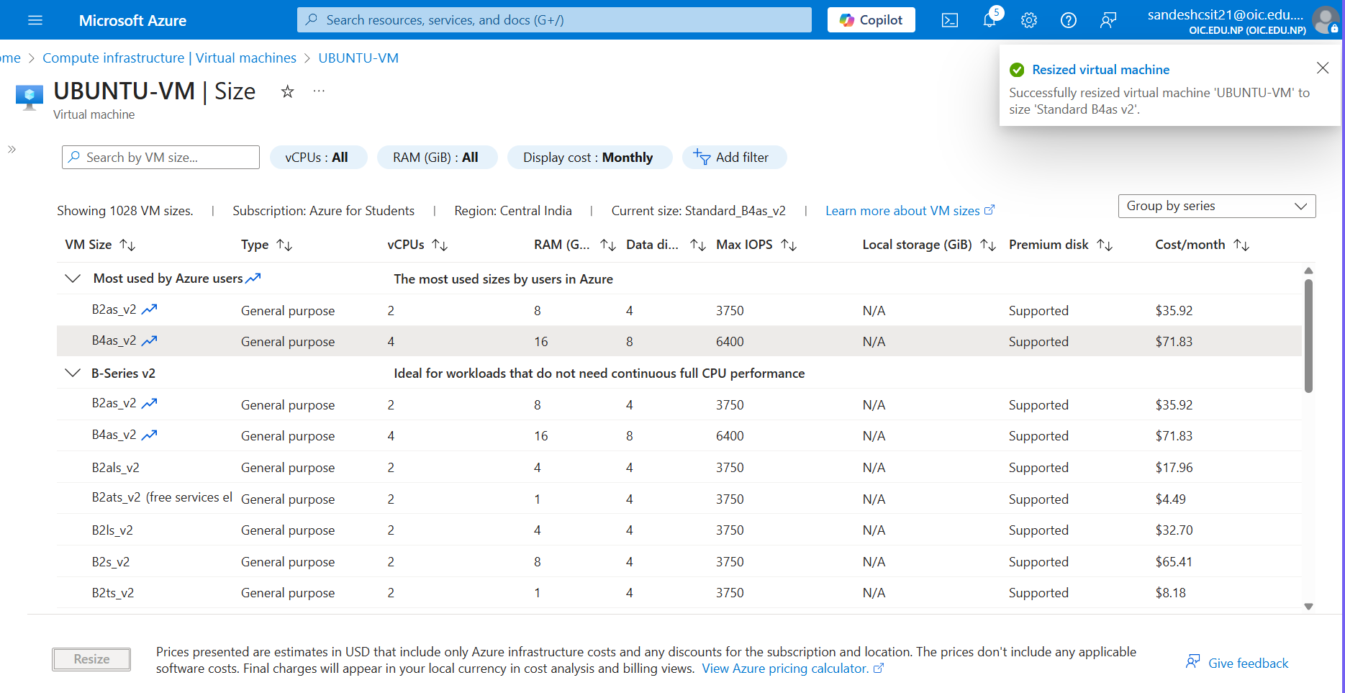

Step 3: Select a New VM Size
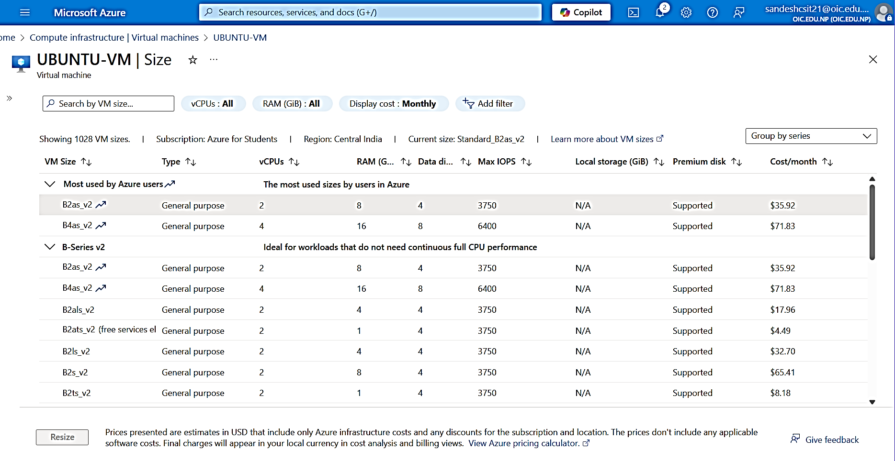

Step 4: Verify New VM Size
